**Qatar University**

**College of Engineering**

**CMPS 405: Operating Systems**

**Fall 2024**

**(Section B04)**

**Project Phase-1**

***Submitted to:***

Dr. Heba Dawoud

|  |  |  |
| --- | --- | --- |
| **Student** | **Name** | **ID** |
| **#1** | Nafin Mahmoud | 201913152 |
| **#2** | Khamis Al-Kubaisi | 201707893 |
| **#3** | Khalid Abdallah | 202106376 |
| **#4** | M.Reyad Tuama Halabi | 201902988 |

**Server-Side Tasks (VM1)**

Task-1:

- Create local user accounts for each client on the server.









- Install and enable SSHD

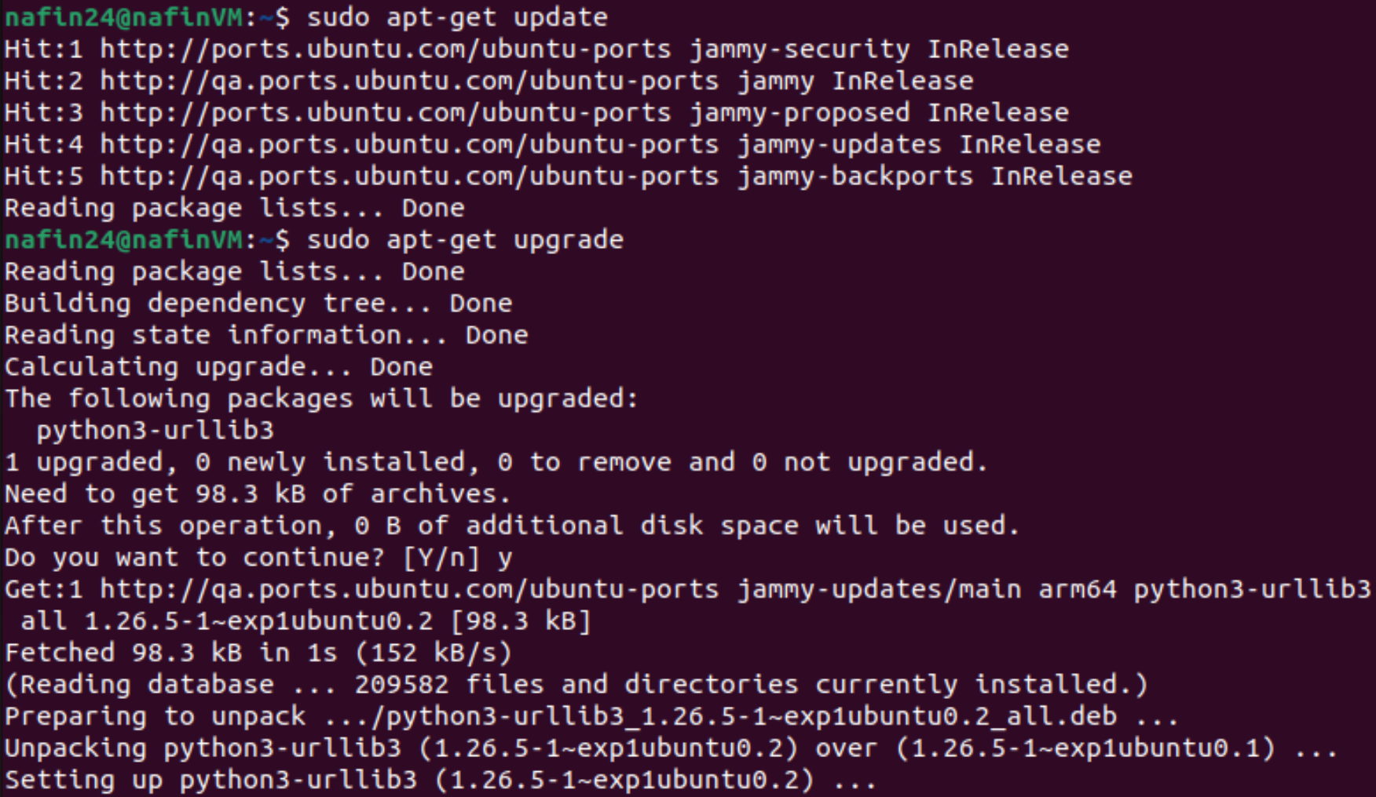

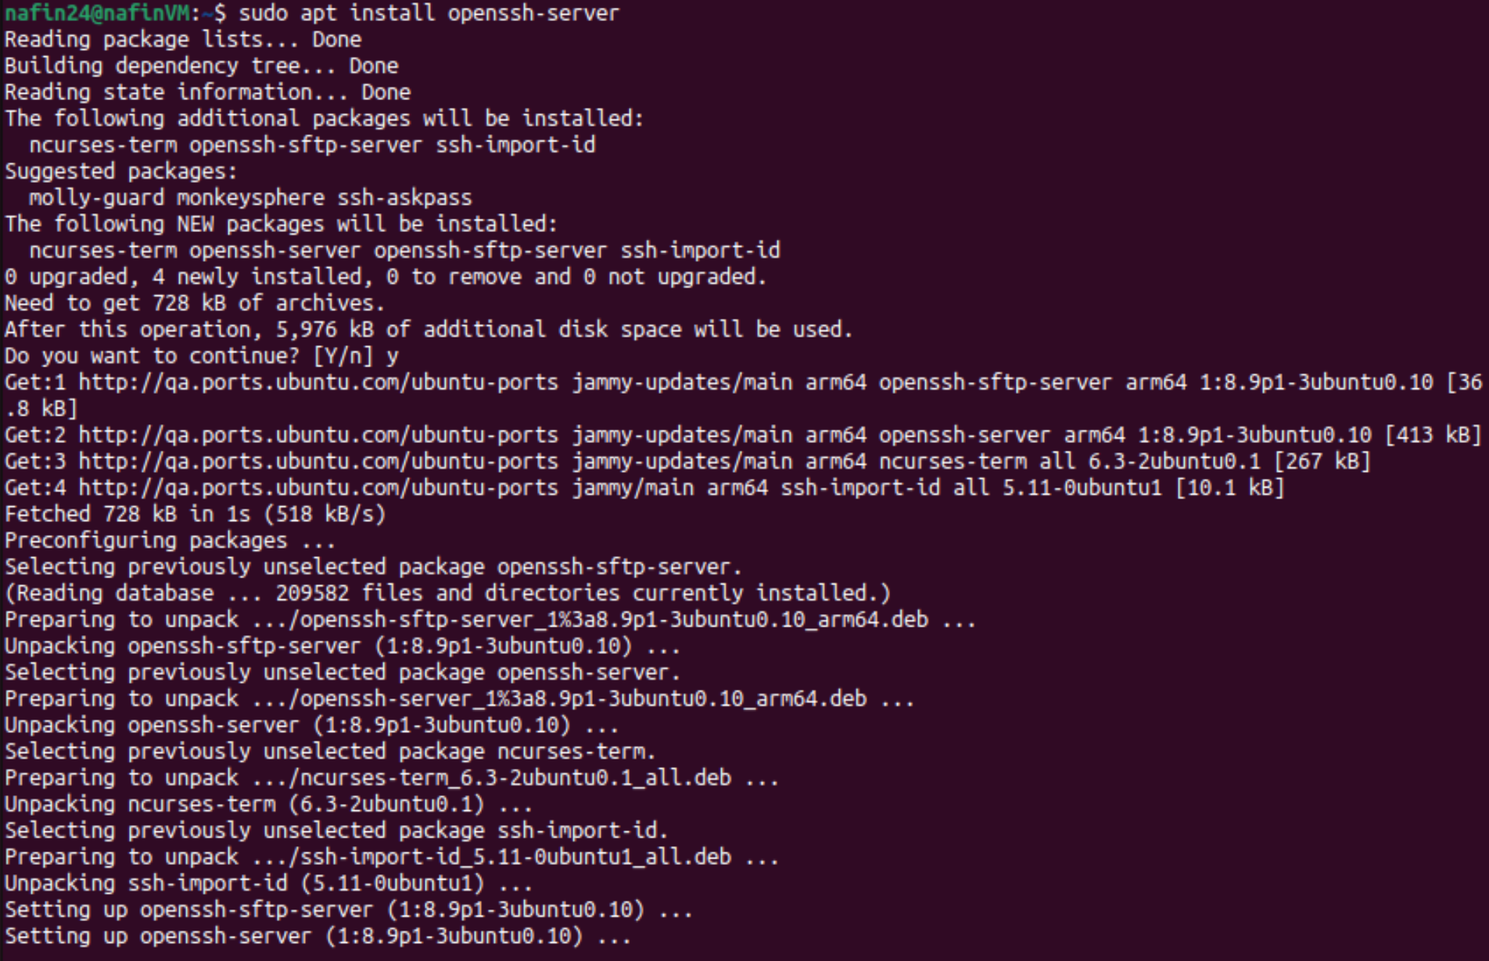



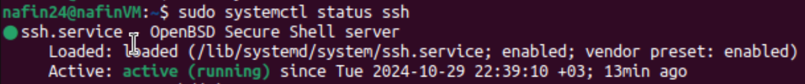

- Configure SFTP for file transfer operations.



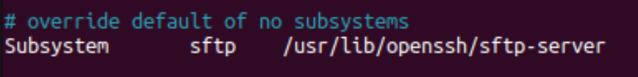

Task-2:

* Enable SSH access for clients using local account credentials, that is, configure SSHD server such that clients can access any file via their local accounts, using username and password.
* Set up SFTP for file uploads/downloads.
* Secure copy will be used to transfer files to and from server.



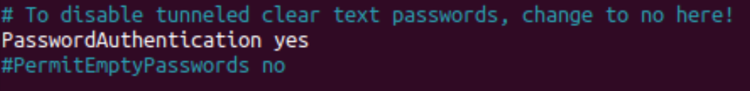



Task-3:

* ***Server-Side Shell script 1: (network.sh)***

#!/bin/bash  
  
# Check if at least one IP is provided  
  
if [ "$#" -eq 0 ]; then  
    echo "No ip was provided"  
    exit 1  
fi  
  
# Check whether ping and traceroute are installed. Otherwise, install all network tools  
if ! command -v ping &> /dev/null || ! command -v traceroute &> /dev/null; then  
    echo "Installing ping and traceroute"  
    sudo apt-get update -y &> /dev/null  
    sudo apt-get install -y iputils-ping traceroute net-tools &> /dev/null  
fi    
  
# Creating log file for network  
log="network.log"  
echo "Testing Connection on $(date)" > $log  
  
# Checking connectivity  
check() {  
    # Taking one IP at a time  
    local target_IP=$1  
    echo "Testing connection for $target_IP"  
  
    # Test with ping  
    if ping -c 3 -W 5 "$target_IP" &> /dev/null; then  
        # If good connection, then log result  
        echo "$(date '+%Y-%m-%d %H:%M:%S') - Testing connection with $target_IP is successful" | tee -a "$log"  
    else  
        # If ping fails, then call traceroute  
        echo "$(date '+%Y-%m-%d %H:%M:%S') - Testing connection with $target_IP has failed, calling traceroute now" | tee -a "$log"  
        ./traceroute.sh "$target_IP"  
    fi  
}  
  
# Check connection for each IP three times  
for i in {1..3}; do  
    for target_IP in "$@"; do   
        check "$target_IP"  
    done  
    echo "Pass no.$i is done"  
done



* ***Server-Side Shell script 1: (traceroute.sh)***

#!/bin/bash  
  
# Check if a target IP was provided  
  
if [ "$#" -eq 0 ]; then  
    echo "No ip was provided"  
    exit 1  
fi  
  
target_IP=$1  
log="network.log"  
  
# Log the start of the traceroute process  
echo "Running traceroute for $target_IP" | tee -a "$log"  
  
# Display routing table  
echo "Routing table:" | tee -a "$log"  
netstat -nr | tee -a "$log"  
  
# Display hostname  
echo "Hostname: $(hostname)" | tee -a "$log"  
  
# Testing local DNS server connection  
echo "Testing local DNS server connection" | tee -a "$log"  
nslookup [google.com](http://google.com) | tee -a "$log"  
  
# Tracing route to google  
echo "Tracing route to [google.com](http://google.com)" | tee -a "$log"  
traceroute [google.com](http://google.com) | tee -a "$log"  
  
# Tracing route to the target IP  
echo "Tracing route to $target_IP" | tee -a "$log"  
traceroute "$target_IP" | tee -a "$log"  
  
# Ping [google.com](http://google.com)  
echo "Pinging [google.com](http://google.com)" | tee -a "$log"  
ping -c 3 -W 5 [google.com](http://google.com) | tee -a "$log"   
  
# Check connectivity to target IP  
if ! ping -c 3 -W 5 "$target_IP" &> /dev/null; then  
    echo "Cannot reach target $target_IP, rebooting now" | tee -a "$log"  
    sudo reboot  
else  
    echo "Reconnected to $target_IP" | tee -a "$log"  
fi



* ***Output samples:***

Testing without providing ip:

Testing client1 VM2 (192.168.66.129):

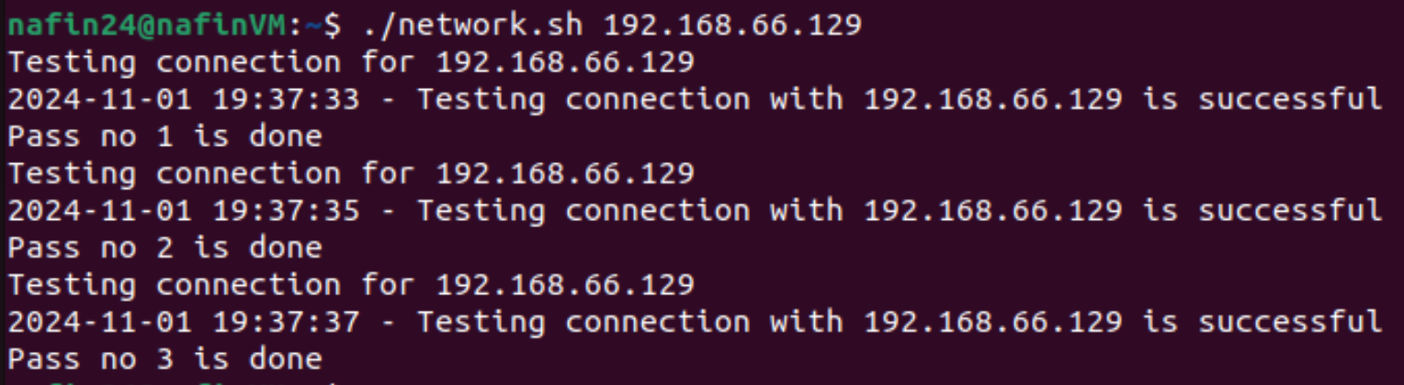

Testing client1 VM2 (192.168.66.129) and client2 VM3 with wrong ip to enforce traceroute:

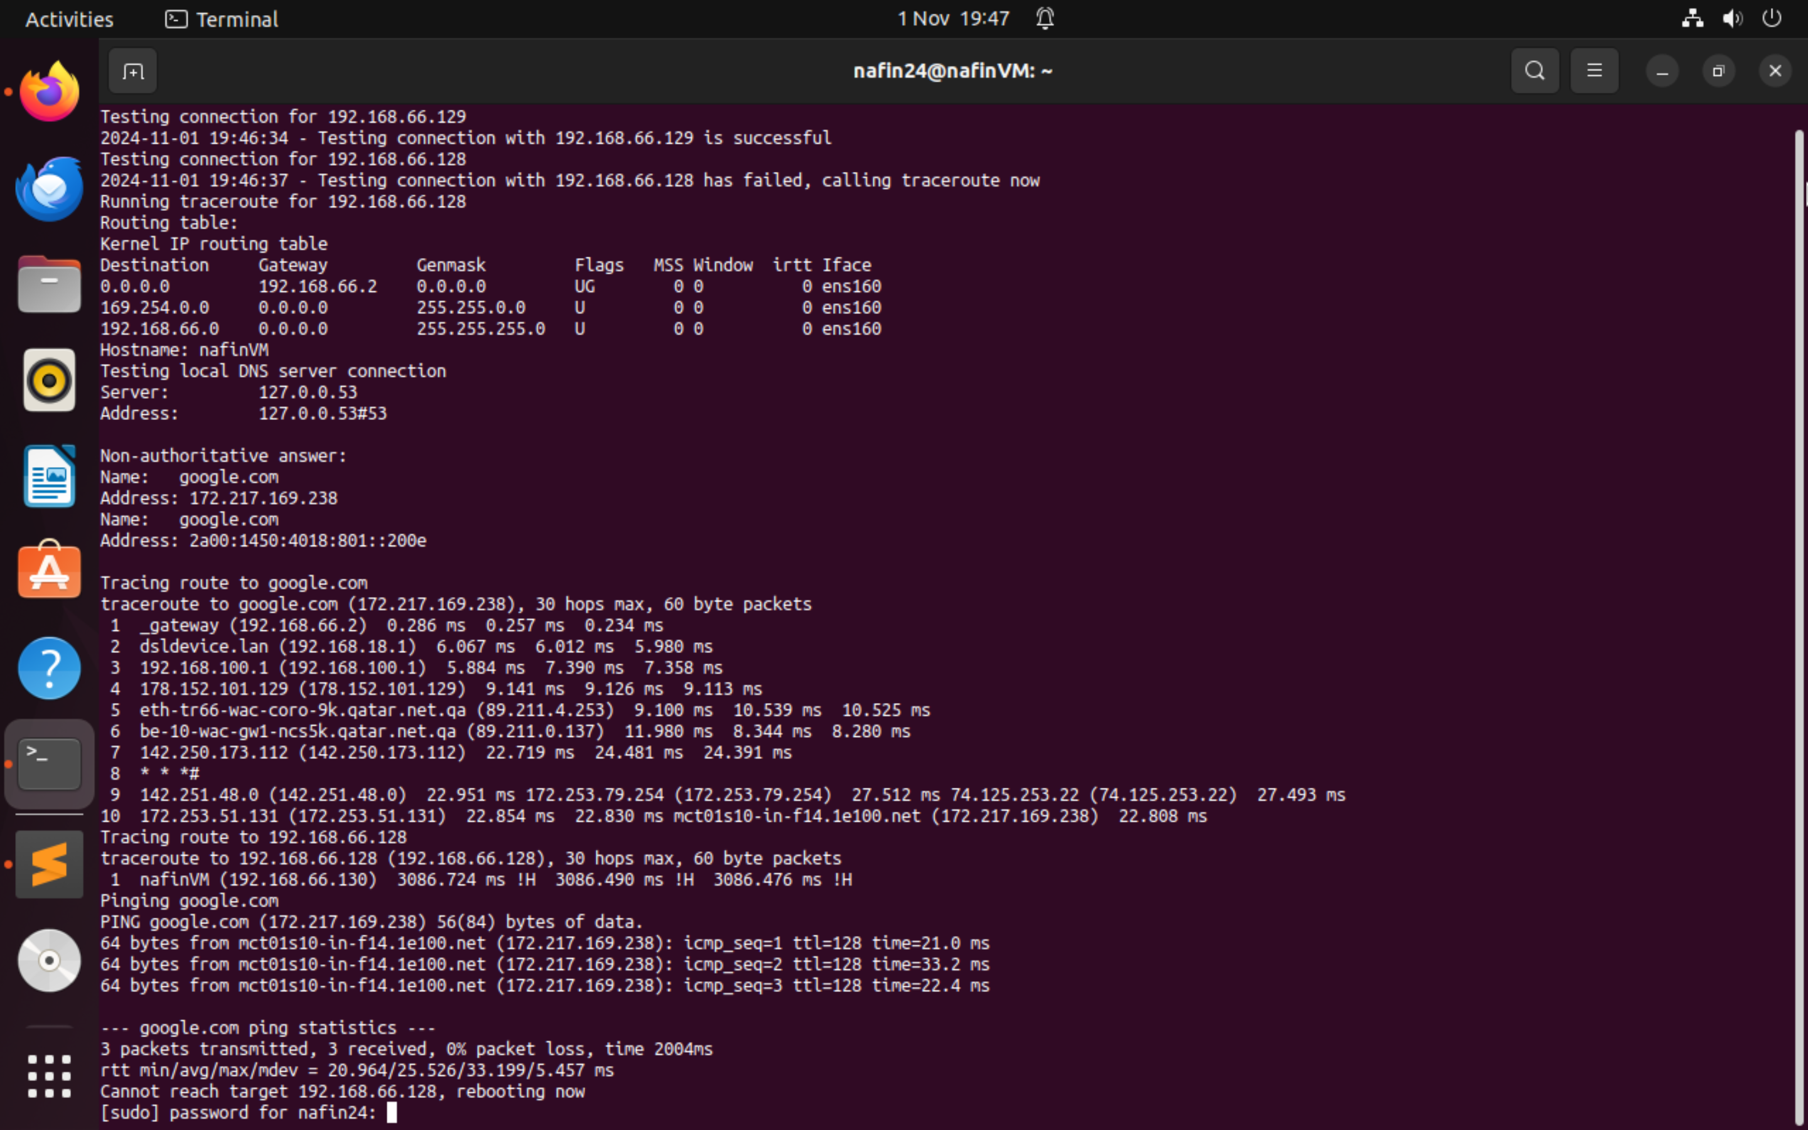

* Log file is created for both scripts

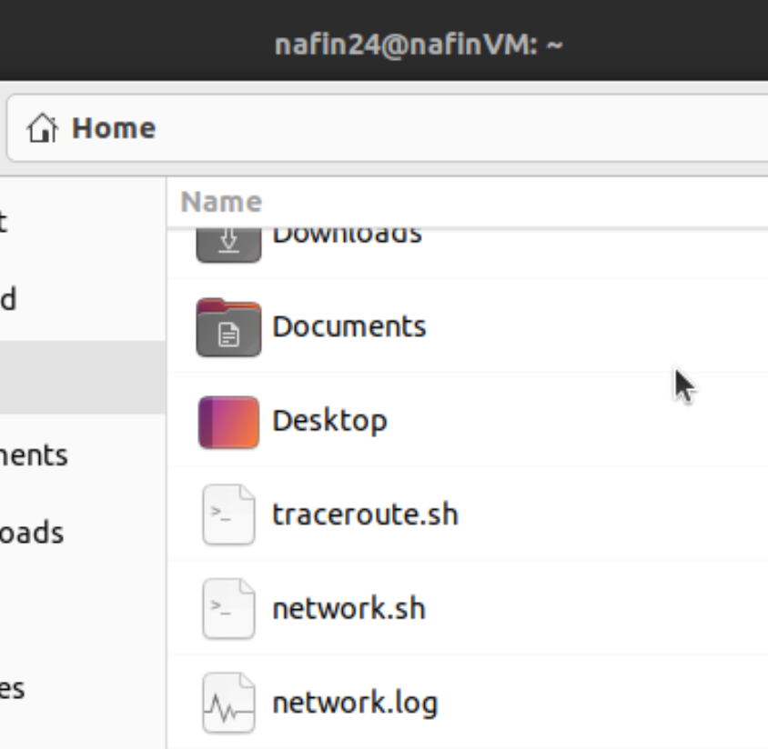

* ***Server-Side Shell script 2: (System.sh)***

#!/bin/bash

# System.sh script

# LOGs

DISK_LOG="disk_info.log"

SYS_LOG="mem_cpu_info.log"

# Disk usage for HOME directory, including subdirectories

echo "Disk usage for HOME directory:" > "$DISK_LOG"

du -h $HOME/* >> "$DISK_LOG"

# Total disk space for the file system containing the home directory

echo "Total Disk Space:" >> "$DISK_LOG"

df -h $HOME | awk 'NR==2{print "Total: "$2", Used: "$3", Available: "$4", Usage: "$5}' >> "$DISK_LOG"

# Memory and CPU information

echo "Memory and CPU Information:" > "$SYS_LOG"

echo "---------------------------------" >> "$SYS_LOG"

# Free and used memory as percentage

free -m | awk 'NR==2{printf "Memory Usage: Used: %.2f%%, Free: %.2f%%\n", $3*100/$2, $4*100/$2 }' >> "$SYS_LOG"

# CPU model and cores

echo "CPU Model:" >> "$SYS_LOG"

lscpu | grep 'Model name' | awk -F: '{print $2}' >> "$SYS_LOG"

echo "CPU Cores:" $(nproc) >> "$SYS_LOG"

# Save information to logs and display the output

cat "$DISK_LOG"

cat "$SYS_LOG"

***Sample Output:***

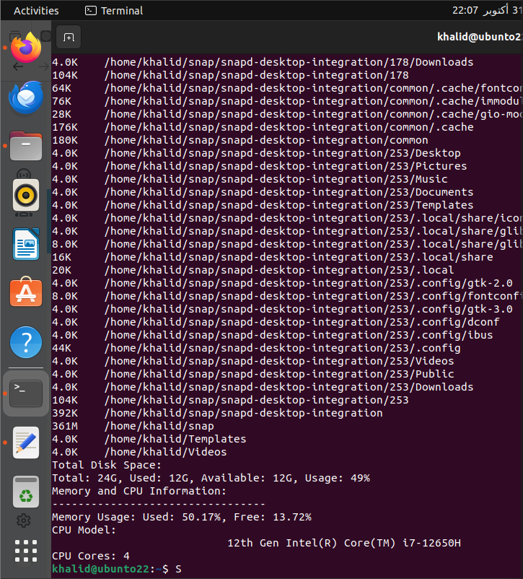

**Client-Side Tasks (VM2 and VM3)**

Task-1:

* Validate that SSH is installed and enabled (SSH is installed by default on most systems).
* Install an SFTP client.

* Ensure SCP (Secure Copy) is available for file transfers.

In client1 VM2:

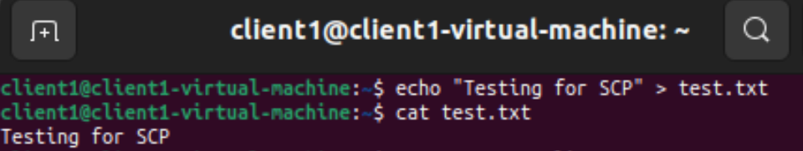

In client1’s directory from server VM1 :

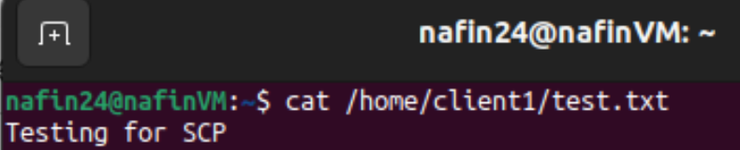

Task-2:

* SSH and SFTP Configuration:

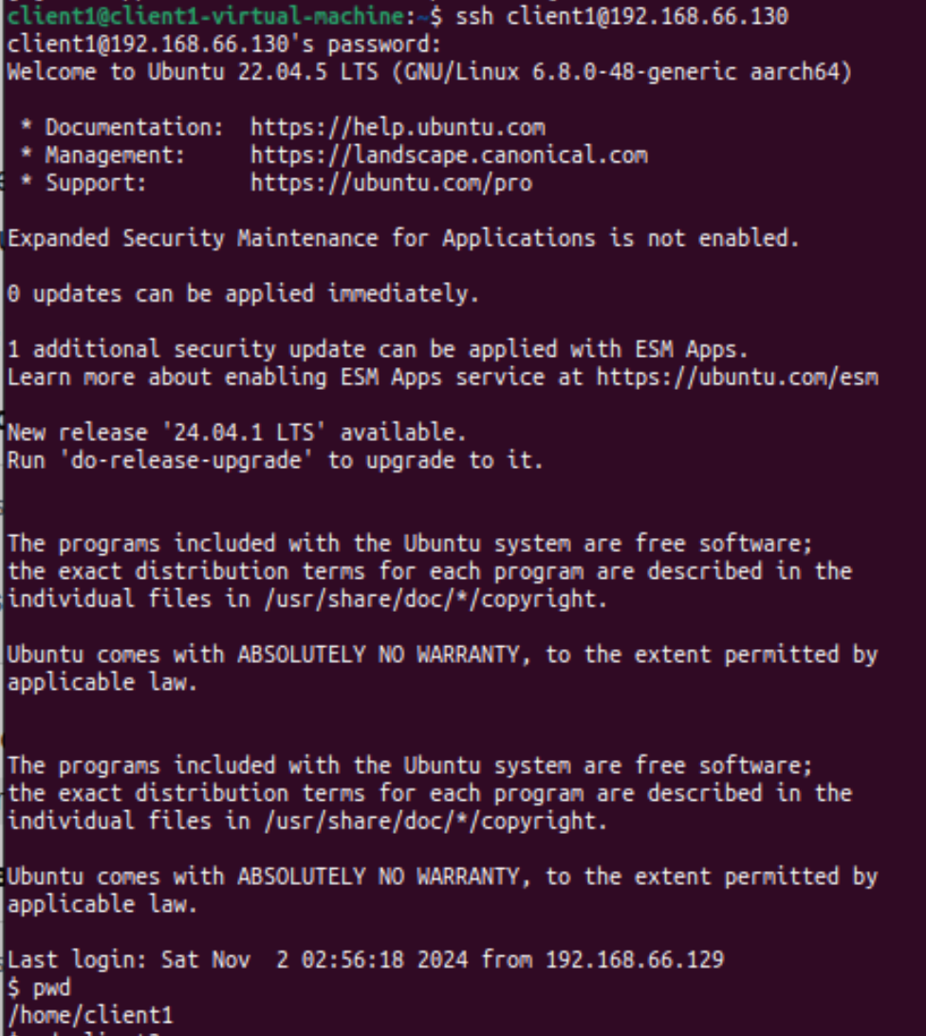



**Client 2 (VM2)**

**Client 2 Side Shell script 1: (Search.sh)**

*#!/bin/bash*

search_files() {

*# Finding the files that are larger than 1 Megabyte in client 2 account:*

*# ((2> /dev/null) is used to redirect error messages to /dev/null to discard them):*

files=$(find ~ -type f -size +1M 2> /dev/null)

*# Piping (files) to (wc -l) to find the number of files larger than 1 Megabyte:*

number_of_files=$(echo "$files" | wc -l)

*# Search date:*

search_date=$(date)

*# Storing the results in (bigfile.log):*

*# (First, we will overwrite the file then we will append the number of files and search date):*

echo -e "$files\n" > bigfile.log

echo -e "Number of files: $number_of_files\n" >> bigfile.log

echo -e "Search date: $search_date" >> bigfile.log

*# Checking if (bigfile.log) is not empty:*

*if* [ -s "bigfile.log" ]; *then*

*# Sending an email using the (curl) command:*

*# Note: 2FA has to be enabled in the email account and an app password must be used:*

curl -s --url 'smtps://smtp.gmail.com:465' --ssl-reqd \

--mail-from "mriyadh1500@gmail.com" \

--mail-rcpt "mriyadh1500@gmail.com"\

--user "mriyadh1500@gmail.com":omgbkpfxhqxknfle \

-T <(echo -e "$(cat "bigfile.log")")

*fi*

}

search_files

**Client 2 Side Script Shell script 2: (Clientinfo.sh)**

*#!/bin/bash*

collect_process_info() {

*# Finding the process tree of all currently running processes:*

ps_tree=$(pstree)

*# Finding the list of all zombie processes:*

zombie_list=$(ps aux | awk '$8=="Z"')

*# Sometimes, there is no zombie processes at all:*

*if* [ -z "$zombie_list" ]; *then*

zombie_list="No zombie processes found."

*fi*

*# Finding processes CPU usage:*

cpu_usage_list=$(ps -eo pid,%cpu,comm)

*# Finding processes memory usage:*

memory_usage_list=$(ps -eo pid,%mem,comm)

*# Finding the top cpu-consuming processes and piping the result to the (head) command:*

*# 6 is used instead of 5 to display the fields line at the begenning:*

top_cpu_usage=$(ps -eo pid,%cpu,comm --sort=-%cpu | head -n 6)

*# Finding the top memory-consuming processes and pinping the result to the (head) command:*

*# 6 is used to display the fields line at the begenning:*

top_memory_usage=$(ps -eo pid,%mem,comm --sort=-%mem | head -n 6)

*# Storing the results in (process_info.log):*

*# (First, we will overwrite the file then we will append):*

echo -e "Process tree:\n$ps_tree\n" > *$1*

echo -e "List of all zombie processes:\n $zombie_list\n" >> *$1*

echo -e "Processes CPU usage:\n $cpu_usage_list\n" >> *$1*

echo -e "Processes memory usage:\n $memory_usage_list\n" >> *$1*

echo -e "Top 5 cpu-consuming processes:\n $top_cpu_usage\n" >> *$1*

echo -e "Top 5 memory-consuming processes:\n $top_memory_usage\n" >> *$1*

}

*while* true

*do*

*# Calling the function and passing the name of the file where process information will be saved:*

collect_process_info process_info.log

*# To connect to the server, we need two pieces of information: 1- IP address 2- Username:*

*# Getting the IP address of the server:*

echo "Enter the IP address of the server: "

read ip_address

*# Getting the username of the account that we want to connect to in the server:*

echo "Enter the username: "

read username

*# Securely copying (process_info.log) to the server:*

*# (scp already uses SSH for transferring files):*

sudo scp process_info.log "$username@$ip_address:/home/client_02"

*# Making sure that (process_info.log) is stored in the server every hour:*

sleep 3600

*done*